
كلية العلوم الحاسوبية والمعلوماتية
Faculty of CSI

Emergency Equipment Management System

Students:
Ihab Saed Afaneh | 202311156
Randa Eid Issa Alja'arat | 202020280
Abdeulmalik Adel Hussein Alrahamnah | 202210728

Supervisor:
Dr. Alaa Al-Dhaoubna

Amman - Jordan
2025/2026

Table of Contents
1.1 Problem Statement and project Scope page 1
1.2 Project Plan and Schedule
2. System Analysis page 2
2.1 Functional Requirements
2.2 Use Case Diagram
3. System Design page 3
3.1 Class Diagram
3.2 ER-Diagram (if a database will be used)
3.3 User Interface

  - Problem Statement and project Scope

The system has been facing problems due to its paper-based appointment
system. With the increase in the number of patients visiting, it has
become diﬃcult to manage the appointment system manually. Recording
of appointments and creating registers by pen and paper has become a
The system has been facing problems due to its reliance on manual and paper-based methods for managing emergency equipment. As the number of equipment items increases, it becomes difficult to track their availability, maintenance status, and expiration dates efficiently. This may lead to expired or unavailable equipment during critical situations, which can pose serious risks to safety.
Problem:" Many organizations such as hospitals, companies, and emergency centers depend on equipment like fire extinguishers, oxygen tanks, and first aid kits. However, without a proper system, managing these resources becomes inefficient and error-prone.

Solution:
The solution is to develop an Emergency Equipment Management System that allows staff to manage equipment efficiently. The system will track equipment details, monitor expiration dates, and ensure availability at all times to enhance safety and readiness.

  - Project Plan and Schedule
Explanation: This image displays a Gantt chart outlining the project plan and schedule for the Emergency Equipment Management System, including phases such as planning, system analysis, design, implementation, and testing.
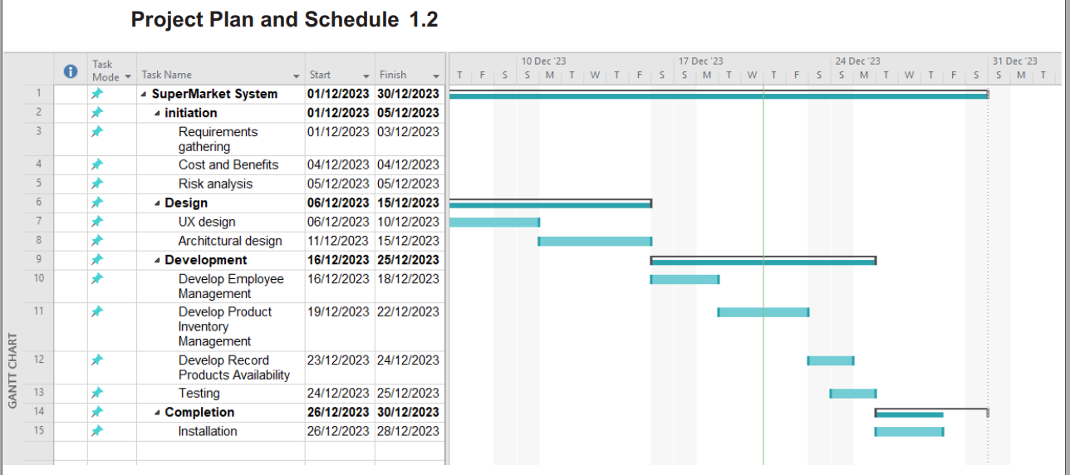

Figure 1

  - 2. System Analysis

2.1 Functional Requirements

1.Equipment Inventory Management
1.1 Staff can add new emergency equipment.
1.2 Staff can update equipment details.
1.3 Staff can delete equipment from the system.

2. Employee Management
2.1 Manager can create and manage employee accounts.
2.2 Employees have role-based access control.

3. Equipment Availability Tracking
3.1 Display all available equipment with details.
3.2 Track expiration dates of equipment.
3.3 Identify expired or unavailable equipment.

2.2 Use Case Diagram
Explanation: This diagram represents a use case model for a system involving a Manager and Employee roles. The Manager can manage employee accounts and emergency equipment, while the Employee can view, add, and update equipment records.
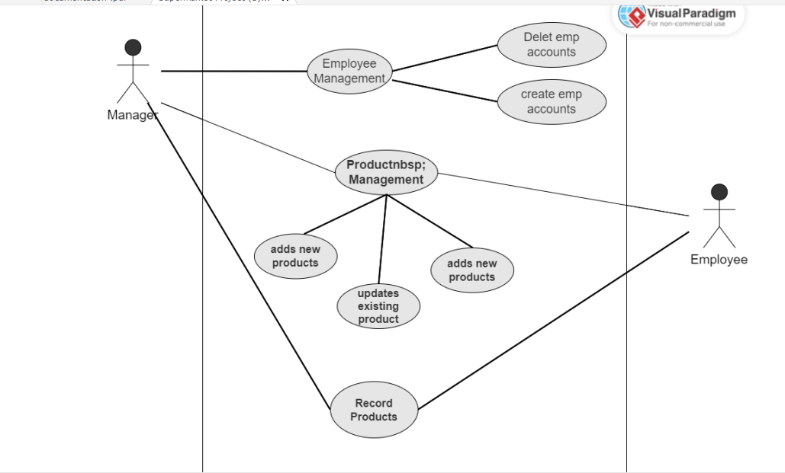
Figure 2

3. System Design

3.1 Class Diagram

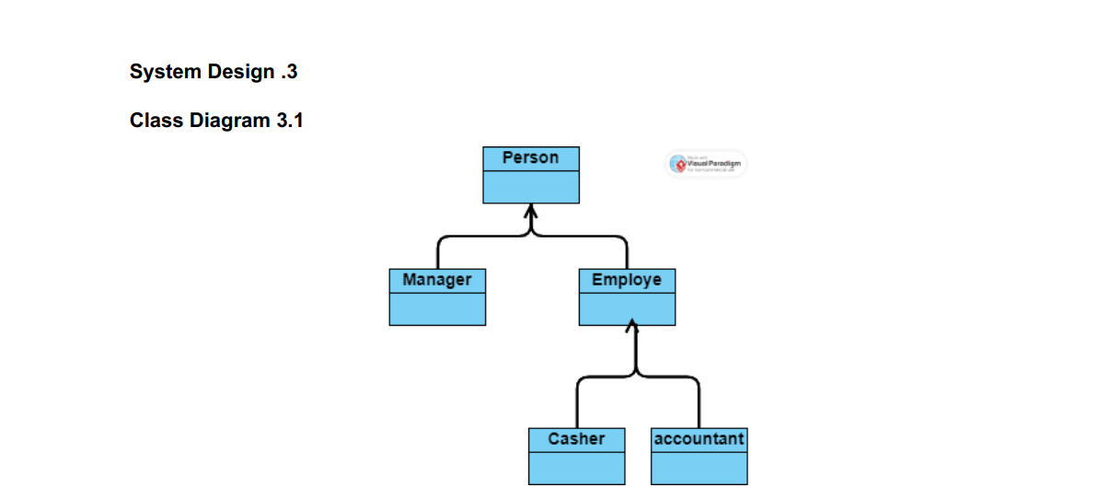

Figure 3

3.2 ER-Diagram
Explanation: This ER diagram illustrates the relationships between Manager, Employee, and Emergency Equipment. The Manager manages employees and equipment, while employees interact with equipment records and updates.
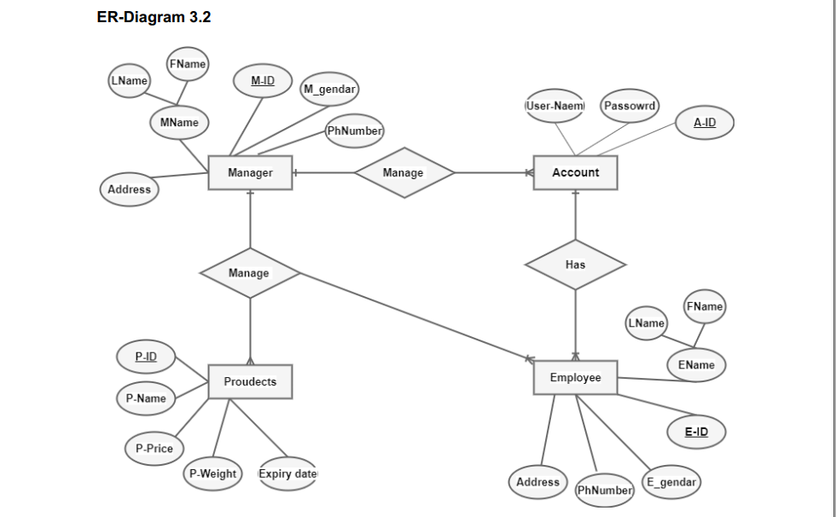 Figure 4

3.3 User Interface

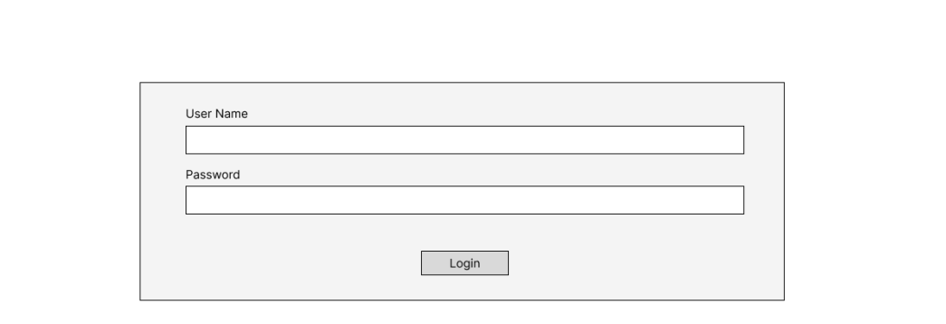

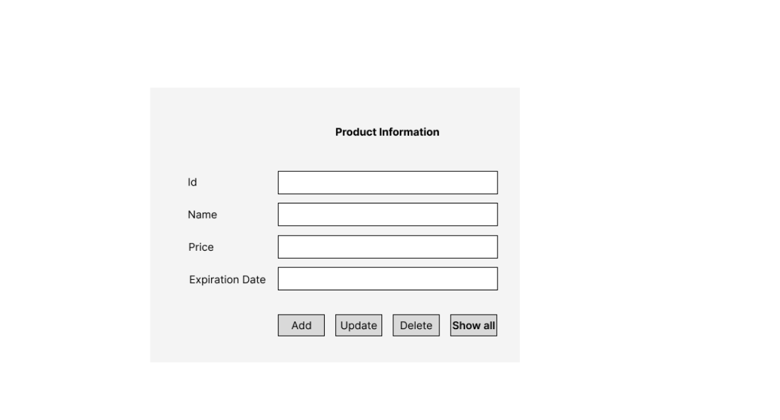

id | Name | Price | Expiration Date | Action
1 | Fire Extinguishe | 50.00jd | 11/10/2026 | Edit || Delete
2 | Oxygen Tank | 120.00jd | 14/8/2026 | Edit || Delete
3 | First Aid Kit | 40.00jd | 11/12/2026 | Edit || Delete
4 | Defibrillator (AED | 500.00jd | 29/5/2026 | Edit || Delete

This table simulates the database table

Figure 6: Show All UI of system

